Parameter: modulation frequency = 5.0; vibration width = 0.01; amplitude = 1.0

(The outputs are attached to this folder.)

Test 1: sweep.wav

Subtract the outputs directly would cause some error. Shown below.

>> plot(data_matlab(1:end,1) - data_rust(1:end,1))

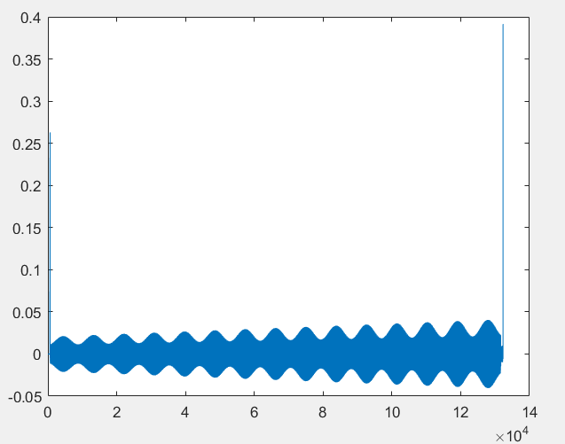

However, on the second inspection, I realized that this is due to the difference in the subscript.

Subtract the index by 1 solves the problem.

>> plot(data_matlab(1:end-1,1) - data_rust(2:end,1))

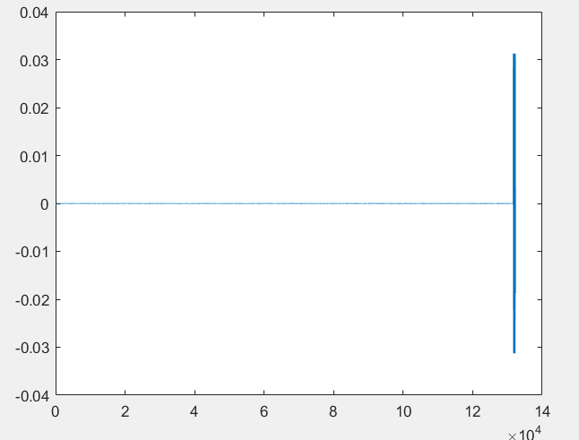

Test 2: stereo_chord.wav. The results are similar.

>> plot(data_matlab(1:end,1) - data_rust(1:end,1))

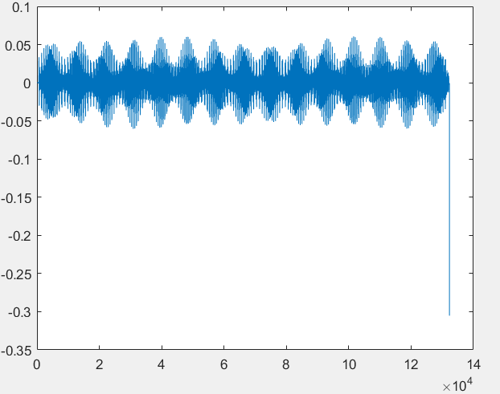

After changing the index:

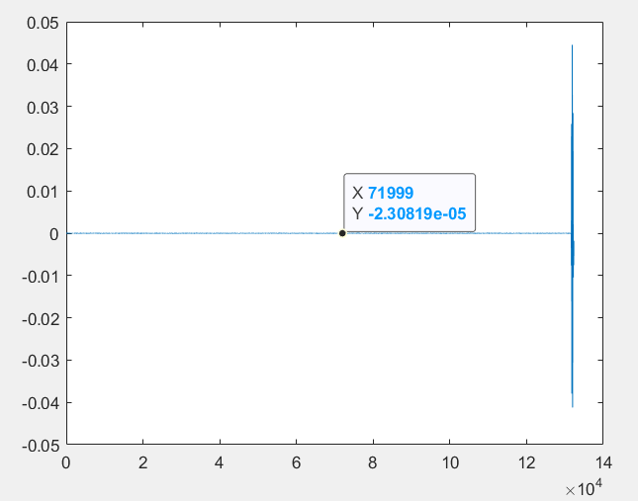

Spoiler: the matlab code can only handle one channel. My code can handle both.